Global Temperature Change Analysis (1961–2022)
A Data Analysis Project
Prepared by: Arush
Dataset: FAOSTAT Climate Change Indicators (FAO)
September 2026

1. Introduction
Climate change is one of the most extensively documented environmental phenomena of the modern era. This project analyzes a country-level dataset of annual temperature anomalies to quantify how global warming has progressed since 1961, which countries have experienced the greatest change, and how the pace of warming compares across decades.
The analysis was conducted entirely in Python using pandas for data processing and Matplotlib for visualization. The full, reproducible code is provided in the accompanying Jupyter notebook, Arush_ClimateChangeAnalysis.ipynb.

1.1 Objectives
- Quantify the trend in global average temperature anomaly from 1961 to 2022.
- Identify which countries have warmed the most and least over the observed period.
- Compare average warming across decades to assess whether the rate of change is accelerating.
- Characterize how warming is distributed across countries in the most recent year of data.

2. Dataset Description
Source | Food and Agriculture Organization of the United Nations (FAO), FAOSTAT Climate Change — Climate Indicators, Temperature Change
Link | https://www.fao.org/faostat/en/#data/ET
License | CC BY-NC-SA 3.0 IGO
Coverage | 225 countries/territories, annual data from 1961 to 2022
Metric | Temperature change (°C) relative to a 1951–1980 baseline climatology
Original format | Wide format — one row per country, one column per year (F1961...F2022)

Before analysis, the wide-format table was reshaped ('melted') into a long-format table with one row per (Country, year) observation, and rows with missing temperature values were dropped. This produced 12,460 valid country-year observations out of an initial 13,950 (225 countries x 62 years).

3. Methodology
- Load the raw CSV and identify the 62 year columns (F1961–F2022).
- Reshape wide-to-long with pandas.melt(), then drop rows with missing anomaly values.
- Compute the global average anomaly per year by averaging across all countries with valid data for that year.
- Rank countries by 'total warming' — the change between their average anomaly in 1961–1965 and their average anomaly in 2018–2022.
- Aggregate by decade (1960s, 1970s, ... 2020s) to compare average anomalies across time periods.
- Examine the distribution of anomalies across all countries in the most recent year (2022) using a histogram.
- Visualize the decade-average anomaly for the 15 most-warmed countries as a heatmap.

4. Results

4.1 Global Temperature Trend
The global average temperature anomaly rose from close to the 1951-1980 baseline in the early 1960s to approximately +1.4°C by 2022, a net increase of about 1.2°C over 62 years. The chart below shows a clear, steady upward trend that becomes markedly steeper after the late 1980s.
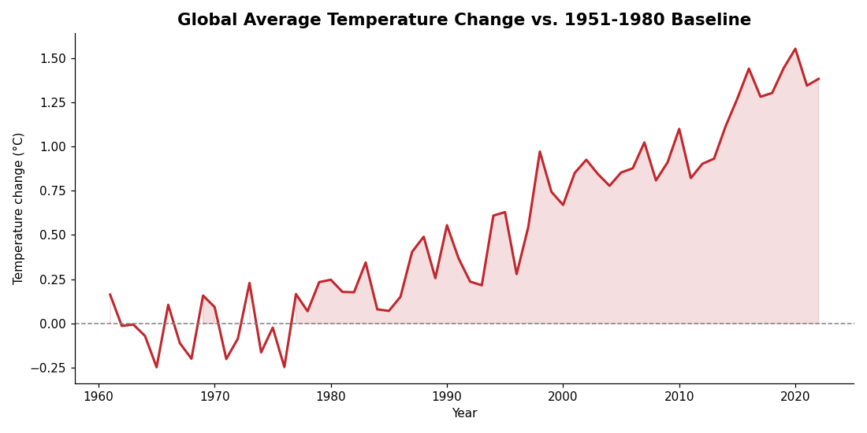
Figure 1. Global average temperature anomaly by year, 1961-2022.

4.2 Countries That Warmed the Most and Least
Comparing each country's average anomaly in its earliest years (1961-1965) to its most recent years (2018-2022) reveals substantial variation. A subset of countries — often at higher latitudes — show anomalies well above the global average, while a handful of countries show little net change or slight cooling over the period.
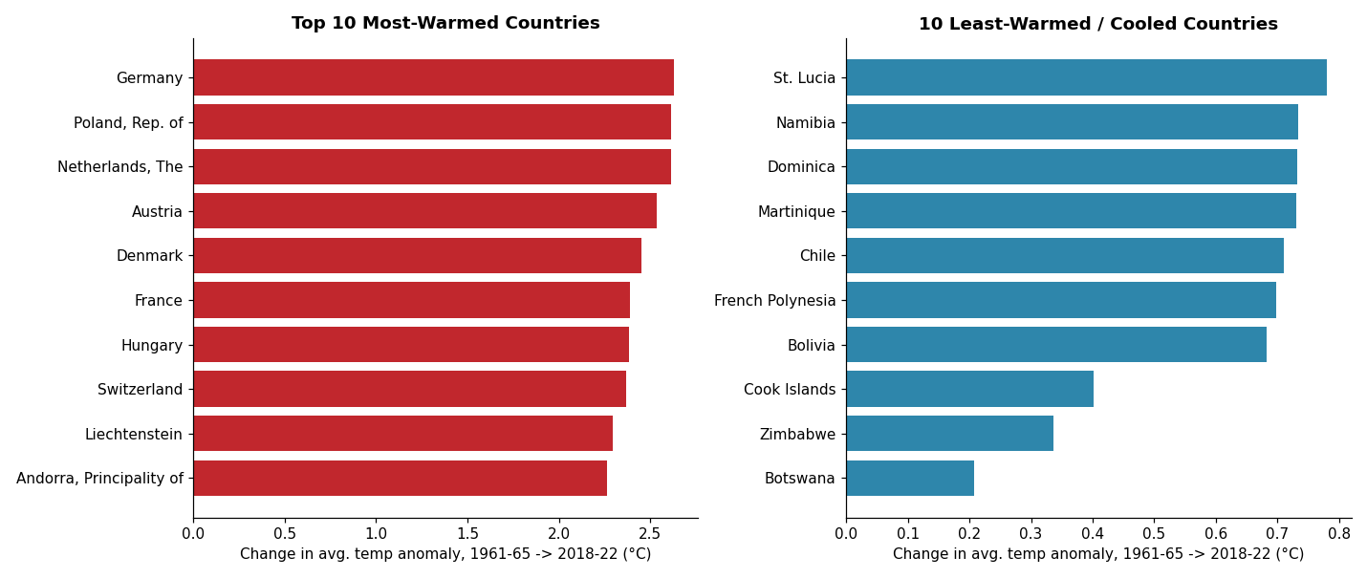
Figure 2. The 10 countries with the largest increase in temperature anomaly (left) and the 10 with the smallest increase or a decrease (right).

4.3 Warming by Decade
Aggregating the anomaly by decade shows a consistent, monotonic increase: each decade since the 1960s has, on average, been warmer than the one before it, with the sharpest jump occurring between the 2000s and 2010s/2020s.
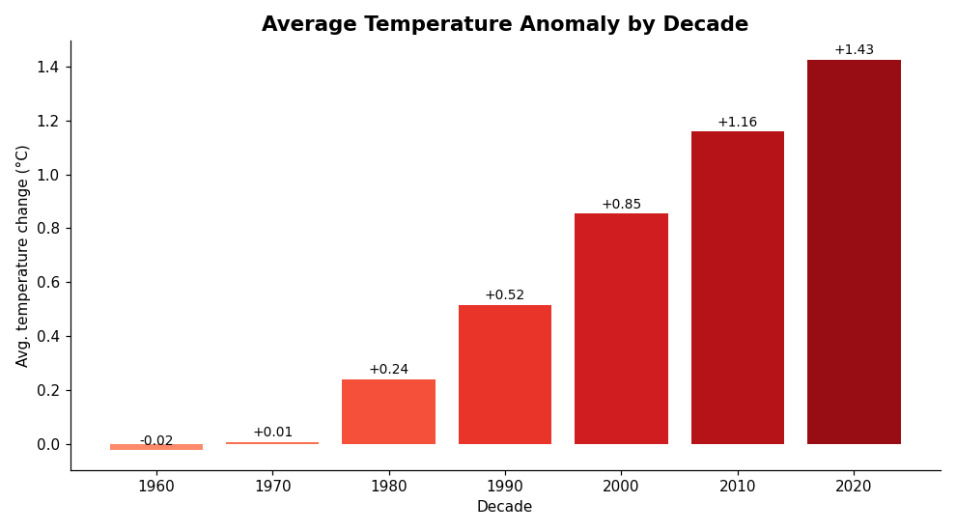
Figure 3. Average temperature anomaly by decade.

4.4 Distribution of Warming Across Countries
In the most recent year of data (2022), country-level anomalies ranged from about -1.3°C to +3.2°C, with a mean of roughly +1.4°C. Most countries cluster between +0.9°C and +1.9°C, but the distribution has a noticeable right tail of countries warming considerably faster than average.
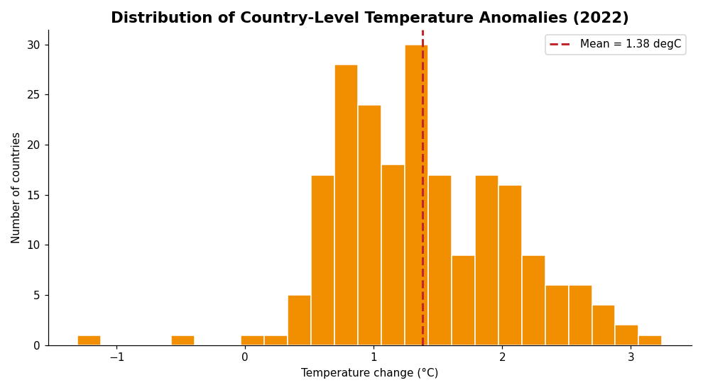
Figure 4. Distribution of temperature anomalies across all countries in 2022.

4.5 Top Warmed Countries Across Decades
The heatmap below tracks the 15 most-warmed countries' average anomaly in each decade, illustrating that their warming trajectories have generally intensified over time rather than being driven by a single anomalous decade.
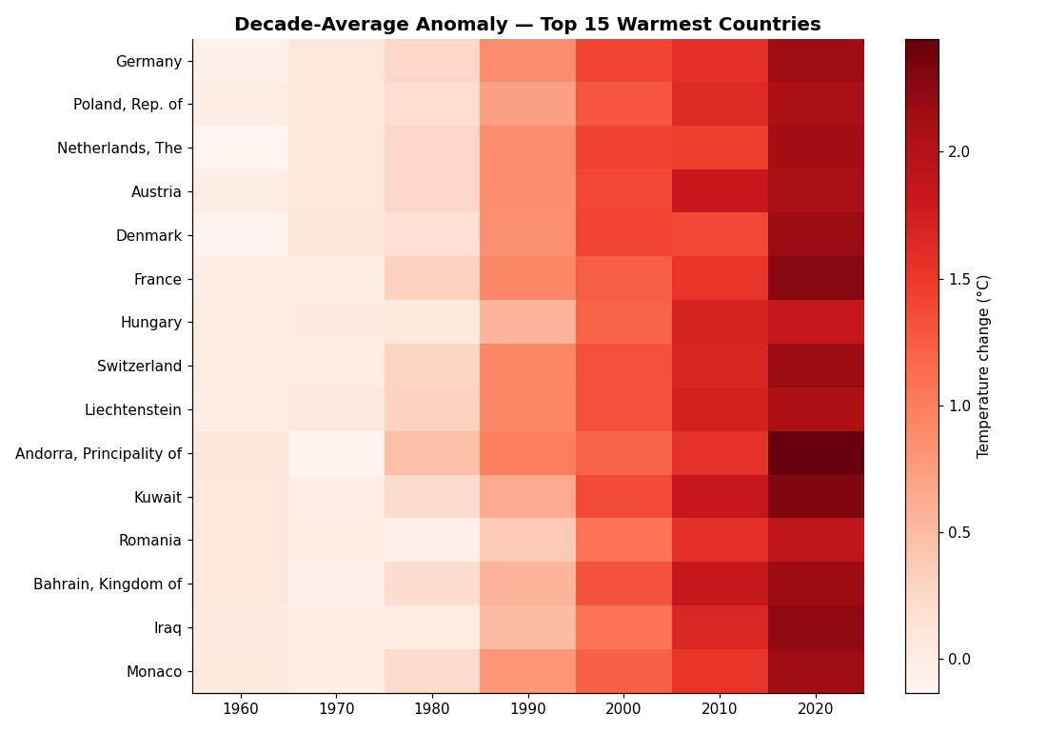
Figure 5. Decade-average anomaly for the 15 most-warmed countries.

5. Key Insights
- Global warming is clear, sustained, and accelerating: the global average anomaly has increased by roughly 1.2°C since 1961, with the fastest rate of increase in the most recent decades.
- Warming is geographically uneven: some countries have warmed far faster than the global average, while a small minority show little to no net warming.
- The decade-by-decade progression is monotonic in this dataset — every decade examined was warmer, on average, than the previous one.
- Even within a single recent year, the spread of anomalies across countries is wide, underscoring that global averages can mask significant regional differences.

6. Limitations
- The dataset measures temperature anomalies relative to a fixed 1951-1980 baseline, not absolute temperatures, so it is suited to trend analysis rather than absolute temperature comparisons between countries.
- Some countries have missing values in earlier years, which could introduce a small bias into rankings that depend on early-period averages.
- Country names and boundaries follow the FAOSTAT source as provided, including dependent territories, without further consolidation.

7. Conclusion
This analysis of FAOSTAT's country-level temperature anomaly data confirms a clear, accelerating global warming trend from 1961 to 2022, with substantial variation in the rate of warming between countries and decades. The accompanying notebook provides the full, reproducible code, and the README explains how to re-run the analysis.

8. References
Food and Agriculture Organization of the United Nations (FAO). 2022. FAOSTAT Climate Change, Climate Indicators, Temperature change. License: CC BY-NC-SA 3.0 IGO. Extracted from: https://www.fao.org/faostat/en/#data/ET.

